**All components of this case study have to be executed in R.**

DATA PREPARATION:

1. Make a grouped bar chart depicting the hour-wise trip request made at city and airport respectively. You can aggregate the data for all 5 days on the same axis of 24 hours. Each bar should correspond to an hour and pick-up point (city / airport) should be displayed in two colors.

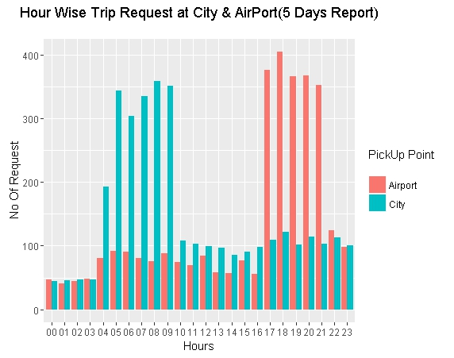

1. In the bar chart (question 1), you’ll be able to see 5 major time blocks based on the frequency of requests made at the city and airport. You have to now divide the request-time into 5 time-slots described below. Make an additional column “Time_Slot” which takes these 5 categorical values depending on the request time:
   * Pre_Morning
   * Morning_Rush
   * Day_Time
   * Evening_Rush
   * Late_Night

Note: The division of time-slots may not have one right answer.

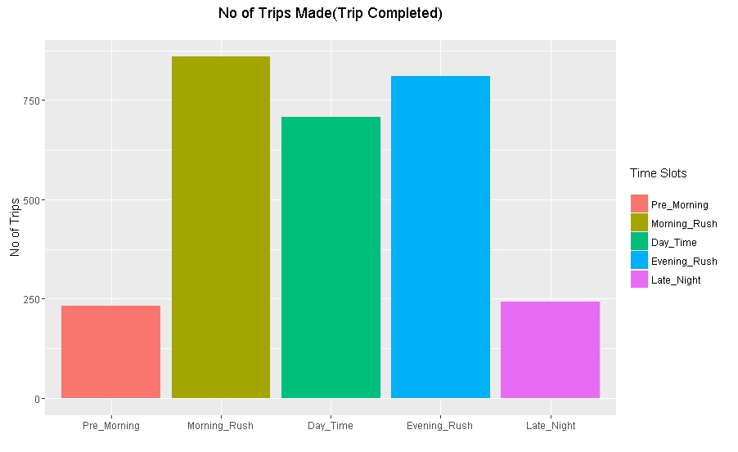

Also give the count of the number of trips made during different time slots you have decided.

* Pre_Morning: - 232
* Morning_Rush: - 859
* Day_Time: - 708
* Evening_Rush: - 811
* Late_Night: - 242

PROBLEM IDENTIFICATION:

1. Make a stacked bar chart where each bar represents a time slot and y axis shows the frequency of requests. Different proportions of bars should represent the completed, cancelled and no cars available out of the total customer requests.

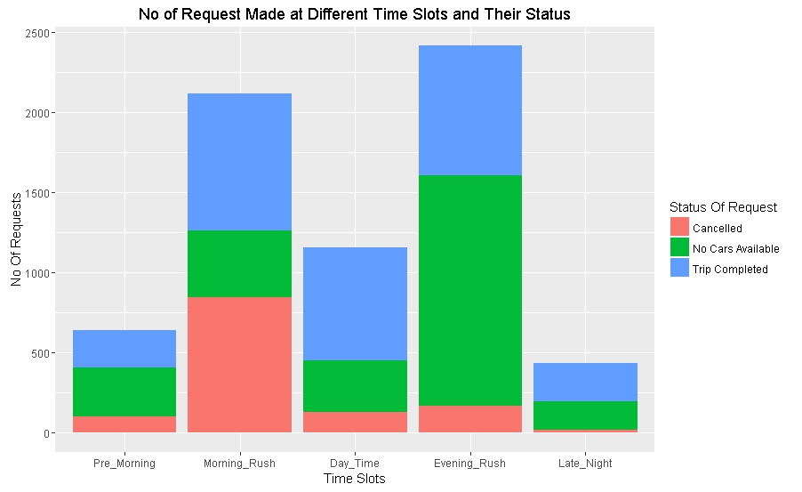

1. Visually identify the 2 most pressing problems for Uber, out of the 15 possible scenarios (5 slots * 3 trip status).
2. Enter your diagnosis results here:

* Problem 1: In Morning Rush out of 2120 Request only 859 were completed, which is only 40% of the total Morning request and 39% of the request were cancelled by the Drivers in the same time slot.
* Problem 2: In Evening Rush hour only 40% of the cars were available and only 33% cars made the trip.

 Problem 1:

1. For the time slot when problem 1 exists, plot a stacked bar chart to find out if the problem is more severe for pick-up requests made at the airport or the city. As a next step, you have to determine the number of times this issue exists in that time slot.

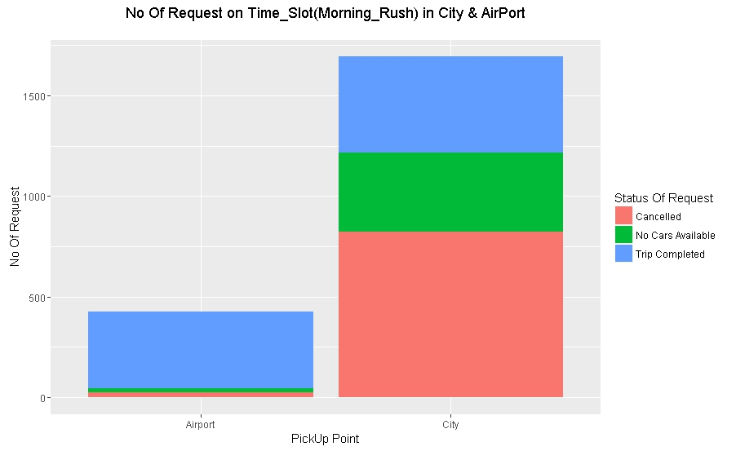

* Find the percentage breakup for the total number of issues in this time slot based on the pick-up point.

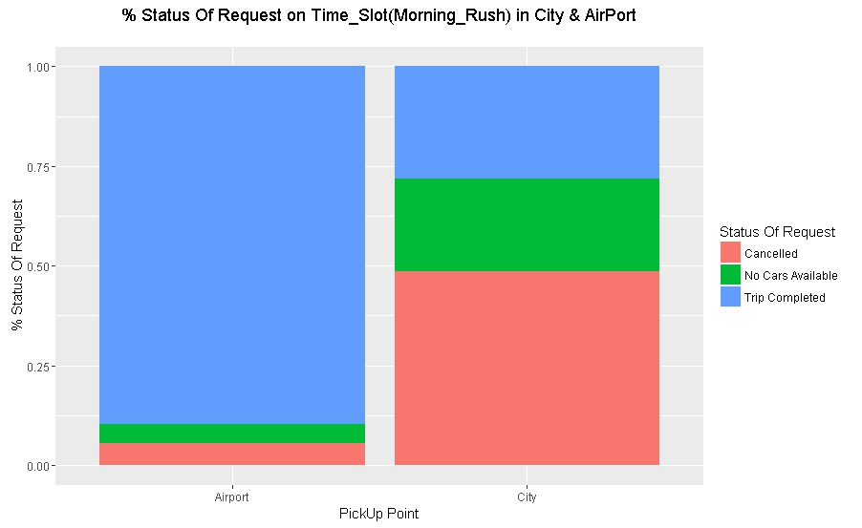

* What is the percentage of total issues at (based on pick-up point):
* Airport :10.30%
* City : 71.88%

1. Now let’s find out the gap between supply and demand. For this case, the demand is the number of trip requests made at the city, whereas the supply is the number of trips completed from city to the airport.

*No. of trip requests made in city: - 1693*

*No. of trips completed from city to airport: - 476*

1. What do you think is the reason for this issue for the supply demand gap? (Write the answer in less than 100 words).

Ans: In City at Morning Rush time slot there is a huge demand for cabs to airport, but this demand is not fulfilled since there is less cars in the City and the drivers which are there, most of them are not willing to go to airport.

1. What is your recommendation to Uber (Not more than 50 words)?

Ans: I would recommend to increase the number of cars in City at Morning Rush hour and to give more weightage in incentives to the drivers if the trip is completed from city to airport on Morning Rush hour.

Problem 2:

1. For the time slot when problem 2 exists, plot the stacked bar chart to find out if the issue is for pick-up request made at the airport or the city. Just like problem 1:

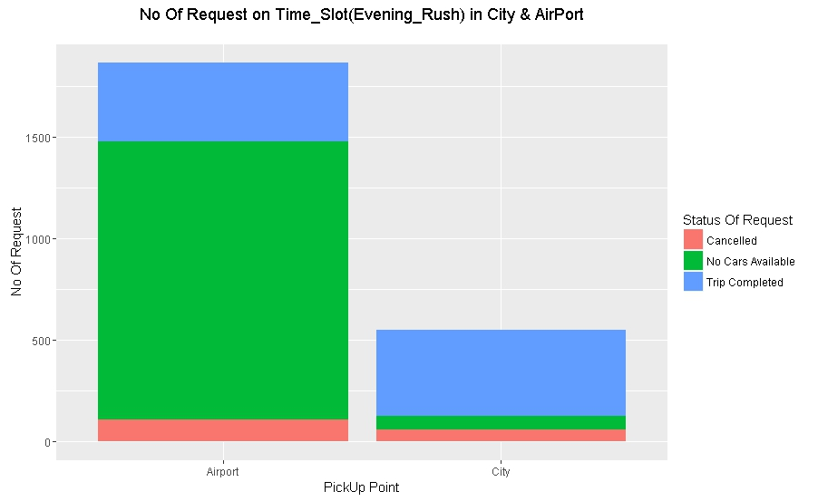

* Find the percentage breakup for issue based on the pick-up point for the time slot in which problem 2 exists.  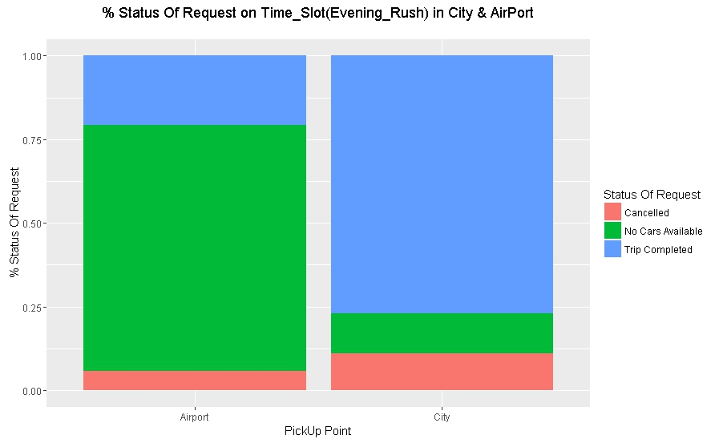
* What is the percentage of total issues at (based on pick-up point):
* Airport : - 79.26%
* City : - 22.90%

1. Now let’s find out the gap between supply and demand. For this case, the demand is the number of trip requests made at the airport, whereas the supply is the number of trips completed from airport to the city.

*No. of trip requests made at the airport: - 1866*

*No. of trips completed from airport to the city: - 387*

1. What do you think is the reason for this issue for this supply demand gap? (Not more than 100 words).

Ans: There is less cars in the airport area during Evening Rush hours and few drivers are not willing to go to city area.

1. What is your recommendation to Uber (Not more than 50 words)?

Ans: Giving more weightage in incentives if the pickup is done from airport to city during evening rush hours.

Conclusion: If a weightage system of incentives(if that’s the motivating factor for drivers) is made based on time slots it may help in meeting the demands.